# Remove Intruder Locked Out

Step 1: Click the **Intruder** menu under Accounts.

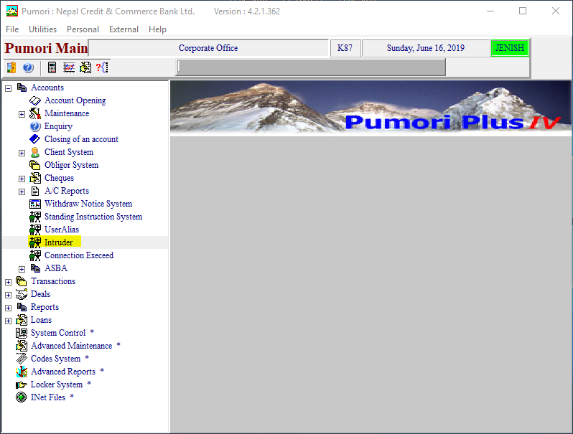

Step 2: Select the locked out user and uncheck “Is Intruder Locked Out”.

